

Date: 10/03/2022

**SYBCA Sem-4**

**Mobile Application Development – Journal**

1. Create an android application which shows the list of various food Items in a list view. Clicking on any food Item will show another activity with the food item details.

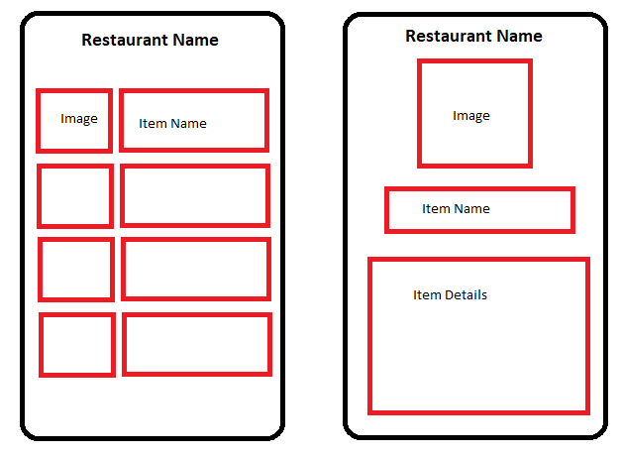

1. Create a flutter application which shows the list of students in a list view. Clicking on any student will show another page with student’s details.

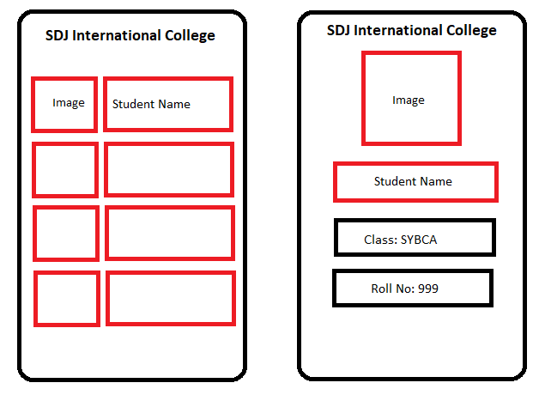

**Note:** Journal Submission date will be announced later.

**Prof. Nehal Patel**

BCA, SDJIC, Vesu